**Weather Station**

**Aim: Measure Humidity, Temperature, Soil Moisture and Air Pressure**

**Components: Firebase, Android App, Esp32, FC-28 and BME280 sensors, etc.**

**Working:** Sensors send the reading to ESP-32, and ESP-32 send data to Firebase, Android app download that data and show the reading on Screen.

**Arduino Code:**

**Output:**

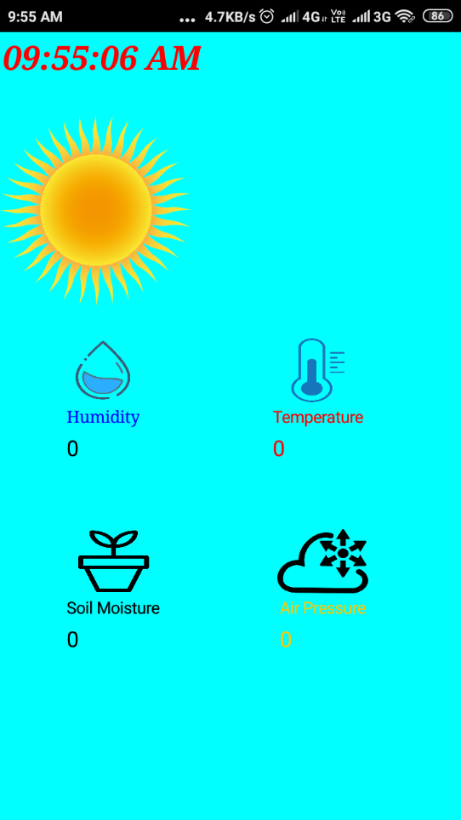

**Application:** Soil monitoring, Weather station, Smart Agriculture, etc.